Research on Scalable Machine Learning for Fraud Detection using Big Data Technologies

Table of Contents
1. Introduction 3
1.1 Research Background 3
1.2 Aim 3
1.3 Objectives 3
1.4 Research Question 4
1.5 Rationale for Choosing the Project 4
2. Literature Review 5
2.1 Machine Learning Models for Fraud Detection 5
2.2 Big Data Technologies and Scalable Fraud Detection 6
2.3 Class Imbalance and Fraud Detection Performance 7
2.4 Critical Research Gap: Accuracy versus Scalability 7
3. Project Design 8
3.1 High-Level Design 8
3.2 Low-Level Design 9
3.3 Requirements and Testing 9
3.4 Risk, Ethics and Project Management 9
4. Results 10
5. Evaluation 11
5.1 User Acceptance Tests 13
6. Conclusion 14
6.1 Summary of Project Achievements 14
6.2 Future Prospects 15
References 16

Introduction

1.1 Research Background
Online transactions and digital financial services have made financial fraud one of the biggest problems for banks, ecommerce companies, insurance companies and digital payment providers. Fraud detection methods, such as rule-based systems and manual auditing are not suited to detecting more complex and widespread fraud. The massive amount of transaction data generated and transmitted continuously, with high volumes, velocity and variety has prompted the need for scalable machine learning solutions that are able to process and analyse big data with efficiency (Liu et al., 2025). Large data technologies like distributed computing platforms, Hadoop, and Apache Spark, can help machine learning models process millions of transactions in real time without compromising on the accuracy of the detection. Machine learning methods such as Random Forest, XGBoost, Gradient Boosting and Deep Neural Networks have proven to be more efficient than traditional statistical methods at detecting intricate fraud patterns. But there are difficulties in scaling, optimizing for computation, model precision and finding rare fraudulent events in extremely imbalanced datasets.

1.2 Aim
This study aims to develop and evaluate a scalable and efficient fraud detection framework using PySpark-based machine learning models for analysing large-scale financial transaction data in real-time environments.

1.3 Objectives
- To preprocess and optimise the fraud detection dataset using PySpark for scalable big data fraud analysis.
- To develop and compare PySpark-based Logistic Regression, Random Forest, and Gradient Boosted Trees models for fraud detection.
- To evaluate fraud detection performance using precision, recall, F1-score, ROC-AUC, and confusion matrix metrics.
- To analyse the scalability, processing efficiency, and real-time performance of machine learning models on large-scale financial transaction data.

1.4 Research Question
- What are the potential benefits of the use of scalable machine learning models that integrate big data technologies for the more accurate, efficient and scalable detection of fraud in large scale financial transaction databases?
- Which machine learning algorithm provides the best performance for detecting fraudulent financial transactions when implemented using big data technologies?
- What impact do big data frameworks have on the computational performance, scalability, and processing time of machine learning-based fraud detection systems?

1.5 Rationale for Choosing the Project
The number of digital financial transactions has grown, and fraud detection has become a crucial area of research for financial institutions and online businesses. Manual fraud detection systems are inefficient for dealing with large volume data and are unable to respond to changing fraud schemes. Recent developments in the field of machine learning and big data technologies offer the chance to create intelligent systems that can handle all the vast amounts of transaction data and detect high-accuracy data in near real time (Liu et al., 2025). The project was selected because it is a problem of practical and economic relevance, which brings two interesting and fast-growing areas together: machine learning and big data analytics. The study introduces new techniques and tools which can also be used in practical applications with real-life data using scalable machine learning algorithms and distributed computing frameworks, adding to both academia and industry. The results can help financial institutions minimize financial damages, boost their efficiency, and enhance their cybersecurity by offering more accurate and scalable fraud detection capabilities (Theodorakopoulos et al., 2025).

2. Literature Review

2.1 Machine Learning Models for Fraud Detection
Digital banking, online payments and electronic financial transactions have gone through a huge scale-up, leading to an upsurge in frauds and financial data. The literature already indicates that machine learning (ML) is one of the key methods used to detect fraudulent transactions in a manner that is able to learn patterns from historical transaction data and detect potentially suspicious transactions. Bello and Olufemi (2024) point to the rising importance of artificial intelligence (AI) in fraud prevention, especially considering the complex nature of fraud schemes that can be difficult for traditional methods to detect. But, the performance of fraud detection with ML techniques also relies on the predictive performance of the algorithms, as well as their ability to handle large amounts of data efficiently. The research problem associated with the proposed study is then related to the challenge of getting accurate, efficient, and scalable fraud detection with growing number of transactions.
Logistic Regression is used as a baseline classification method because it is relatively simple, efficient to compute and relatively easier to interpret than more complex models. Gupta et al. (2025) explores how Logistic Regression is applied to classify banking transactions as fraudulent or non-fraudulent, highlighting the relevance of Logistic Regression in the field of financial fraud classification. It can be useful for financial organisations to know what factors are influencing a prediction, which is what its interpretability provides. Logistic Regression has however its inherent limitation when relationships between transaction attributes and fraud are very non-linear and/or have complicated interactions. It serves as an adequate benchmark, but may not reflect the more sophisticated types of fraud (Naghipour et al., 2025).
Other models like Random Forest and Gradient Boosted Trees are capable of modelling other complex relationships. Random Forest is an aggregation of multiple decision trees that can capture the nonlinear relationship between the features of the transactions; Gradient Boosted Trees are a series of decision trees that enhance predictive performance in an iterative manner. Results obtained from the literature survey discussed in the research proposal suggest that the models based on trees can get better accuracy while detecting fraud, as they can manage complex transaction patterns (Gupta et al., 2025). However, there might be more computational needs in the improvement of predictive capability. When the goal is to develop a scalable fraud detection framework, then picking the model that gets the highest classification accuracy might not be enough.

2.2 Big Data Technologies and Scalable Fraud Detection
The rise of digitization in financial transactions has created a large amount of financial transaction data. As financial data becomes larger and becomes more fraudulent, the growing importance of fraud detection approaches that can cope with such large-scale financial data and increasingly sophisticated fraudulent behaviour is identified by Cheng (2025). As the volume of data continues to increase in complex applications, traditional machine learning approaches can become inefficient due to the inability to process the data on a single machine. This results in the need for distributed computing technologies that are efficient in processing large amounts of data. Apache Spark and PySpark offer a crucial technological solution as they enable distributed data processing of computational resources. Large datasets can be partitioned in PySpark and then processed in parallel so they are appropriate for large-scale analysis workloads. In the literature review has been done and PySpark is identified as an important technology for computation of large financial data. Furthermore, Spark ML pipelines can incorporate data preparation, feature processing, model development and evaluation into a structured machine learning workflow. In his study Hareram (2025), it gives a review of Apache Spark and PySpark with the perspective of distributed data processing, which makes them suitable for big-data machine learning tasks.
Scalability is not just being able to process a larger dataset, however. The fraud detection system has to be scalable, meaning that its predictive accuracy must not suffer significantly when the number of transactions to be processed increases, and it has to operate within a reasonable timeframe for computing. One limitation of the current research identified by the researcher is the lack of focus on the processing efficiency and scalability of the algorithms, in favour of prediction accuracy. This indicates that a good model for a relatively low number of data points is not necessarily best suited for financial environments with a large number of data points. The proposed research aims to go beyond the traditional model-comparison approach and use Logistic Regression, Random Forest and Gradient Boosted Trees with PySpark. This provides the study a chance to explore how accurate the models are, but also how efficient in computation. This will enable the study to investigate predictive success and computation efficiency, not just the accuracy of the models. This is particularly applicable to financial institutions where the speed of transaction is critical as well as the correct classification.

2.3 Class Imbalance and Fraud Detection Performance
In financial fraud detection, the problem of class imbalance is significant due to the fact that fraudulent transactions usually constitute a smaller part of the total number of transactions. This means that a machine learning model can have a high overall accuracy and still have a low accuracy in recognizing fraudulent transactions. The research proposal clearly states that imbalanced datasets of fraud can be a factor to impair prediction, particularly the recall and minority-class classification. Owen et al. (2024) research the effect of class imbalance on fraud detection algorithms and conclude that traditional performance metrics should be used with caution in highly imbalanced databases. For instance, a model that is able to predict most transactions as legitimate may have a high accuracy score if there are many more legitimate transactions than fraudulent ones. This model from a practical point of view would be of little use since the main objective of fraud detection is to detect the minority fraud class.
Therefore, the study proposes using multiple metrics for evaluation such as the precision, recall, F1-score, ROC-AUC, and confusion matrices. These measures offer a more comprehensive evaluation of model performance. It is especially important with regard to recall, which represents the percentage of true fraudulent transactions that can be correctly identified by the model. Precision is also crucial as a large number of false positive predictions could lead to legitimate transactions being flagged up as fraudulent. The F1-score is a combined precision and recall score, and is therefore useful when the dataset is imbalanced. Class imbalance is also an issue for comparisons between algorithms. A model with accuracy of 90% can have a poor recall, while another model can have a greater number of false positives but a better number of fraudulent cases. So, there should be more than one measure of model performance to consider when choosing a model. It helps to give substance to the methodology put forward in the study (Wiltshire & Alvanides, 2022).

2.4 Critical Research Gap: Accuracy versus Scalability
The literature indicates that there is a great lack of research on the accuracy of the fraud detection and computational scalability. Previous research has shown that machine learning algorithms can be useful, and distributed technologies like PySpark are possible. But there is very little research that has been conducted to compare the various models of fraud detection in PySpark, and at the same time, look at the predictive performance, processing efficiency, and scalability. One drawback about an accuracy-based assessment is that the best model for prediction may not be the one that is most appropriate for financial applications in the big data sense. Overcoming the limitations of simple ensemble classifiers can lead to improved classification accuracy, but at the cost of increased computation. On the other hand, a more straightforward model like Logistic Regression could offer quicker computation time but might lack the ability to detect the intricate fraud schemes. This presents a working compromise between accuracy and computational cost which needs to be explored further.
The proposed research aims to fill this gap by building and comparing Logistic Regression, Random Forest and Gradient Boosted Trees in a PySpark framework. The precision, recall, F1-score, ROC-AUC and confusion matrices will be used to evaluate the models and scalability, processing and real-time performance will also be taken into consideration. The comparative approach is important because it addresses a question that goes beyond the traditional "best prediction algorithm" to explore the question of which algorithm is most suitable for the challenge of having a large amount of financial transaction data and the need to develop a prediction model that is scalable and appropriate. Thus, the research directly contributes to filling the aforementioned gap in the literature and contributes to the development of a scalable fraud detection analytics framework, based on PySpark ML pipelines.

3. Project Design
The project aims to create a scalable machine learning fraud detection system that processes large-scale financial transaction data, builds predictive models, and assesses the accuracy and speed of fraud detection, as the design centres around handling vast amounts of financial transaction data and evaluating the effectiveness and efficiency of the predictive models. The project is based on IEEE-CIS Fraud Detection dataset available in Kaggle. The implementation loads the transaction data and the identity data separately, and then joins them based on the TransactionID, resulting in a combined dataset of 590,540 records and 434 columns.

3.1 High-Level Design
The system is a sequential data analytics system, dataset acquisition, loading, inspection, preprocessing, feature engineering, exploratory analysis, model training, model evaluation, scalability analysis. Distributed processing environment: PySpark; Machine learning pipeline and classification: Spark MLlib. For comparison, Logistic Regression, Random Forest and Gradient Boosted Trees models are selected to enable the comparison between linear and ensemble-based approaches. The notebook also sets up the configuration of Spark and the parallel processing to ensure scalable computation.

Figure 1: Sequential data analytics architecture

3.2 Low-Level Design
The low-level components of data preprocessing include selecting 49 numerical and 15 categorical features, handling missing values, using a StringIndexer and OneHotEncoder to transform the categorical features, and merging features with a VectorAssembler. The solution to the class imbalance is to use weighted observations, in this case a higher weight is assigned to the fraud class. The data set is then split into 80% training and 20% testing data.

3.3 Requirements and Testing
Data ingestion, data pre-processing, feature transformation, Model training, Prediction and Performance evaluation are the functional requirements. Scalability, computational efficiency and reproducibility are examples of non-functional requirements. System testing will be conducted for accuracy of data processing, running of models, generation of predictions and outputs of evaluations. The implementation records training time and assesses the accuracy, precision, recall, F1-Score and ROC-AUC which serves as evidence for automated testing and performance comparison (Naghipour et al., 2025).

3.4 Risk, Ethics and Project Management
The design also includes risk assessment for class imbalance, computational constraints, data-quality issues, model performance. Ethical requirements include responsible handling of financial data, privacy and avoidance of biased fraud predictions. Version control, systematic documentation, and reproducibility of the project will be facilitated via a GitHub repository to maintain the project's code and development evidence.

Results
The fraud detection system successfully transformed the dataset of financial transactions from IEEE-CIS and was able to process it through PySpark. The transaction data consisted of 590,540 records and 394 columns, and the identity data had 144,233 records and 41 columns. The resulting dataset was merged with both and had 590,540 rows and 434 columns. It was found that there is a significant class imbalance with 569,877 legitimate transactions and 20,663 fraudulent transactions, which equates to a fraud rate of around 3.50%.
49 numerical and 15 categorical features were identified during data preprocessing. Numerical missing values were replaced by a sentinel value and categorical missing values were coded as a different category. StringIndexer and OneHotEncoder were used to transform the categorical variables and the features were combined by using the VectorAssembler. Class weighting was employed, which resulted in a fraud weight of 14.290 vs. a legitimate weight of 0.518. The data was then split into training (472,404) and testing (118,136) sets.
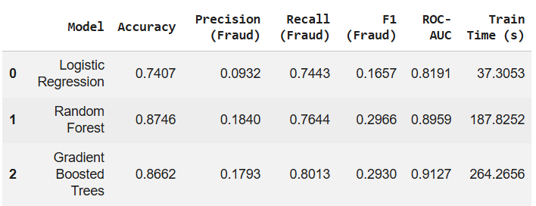
Figure 2: Model Comparison
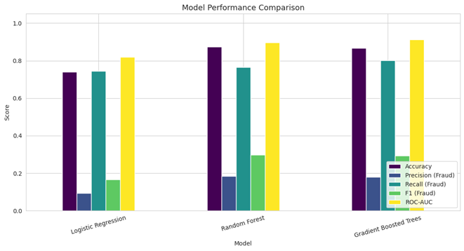
Figure 3: Model Performance Comparison
Three models were designed and tested. Logistic Regression gave 74.07% accuracy, 9.32% precision of fraud, 74.43% recall of fraud, 16.57% F1-score, 0.8191 ROC-AUC and the training time was 37.31 seconds. With the increase in training time to 187.83 seconds, Random Forest performance was enhanced to 87.46% accuracy and 0.8959 ROC-AUC with fraud recall of 76.44% and F1-score of 29.66%.
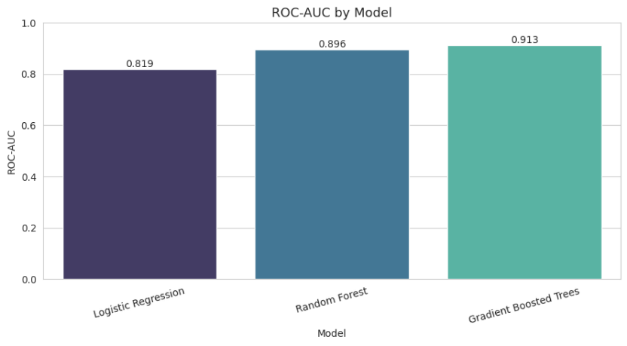
Figure 4: ROC-AUC by Model
The Gradient Boosted Trees model achieved the highest overall accuracy, with a score of 86.62%, a precision of 17.93%, a recall of 80.13%, a F1-Score value of 29.30% and a ROC-AUC value of 0.9127; it took 264.27 seconds to train. In general, the findings show that Gradient Boosted Trees achieved a best fraud-class discrimination, whilst Logistic Regression was much faster. The performance result in the ROC comparison indicates that the GBT has outperformed the Random Forest and Logistic Regression.

Evaluation
The project was assessed based on its primary objective: creating a scalable and efficient fraud detection system with PySpark machine learning technology. The project goals were reflected in the evaluation, which included both the degree of predictive performance and computational efficiency. Three models were implemented—Logistic regression, random forest and gradient boosted trees—evaluated with accuracy, fraud precision, fraud recall, F1 Score and ROC-AUC. For this reason, the multi-metric evaluation was relevant as the dataset was highly imbalanced, meaning that the accuracy alone may give a false impression. Class imbalance was identified as a specific challenge in fraud detection in the project.
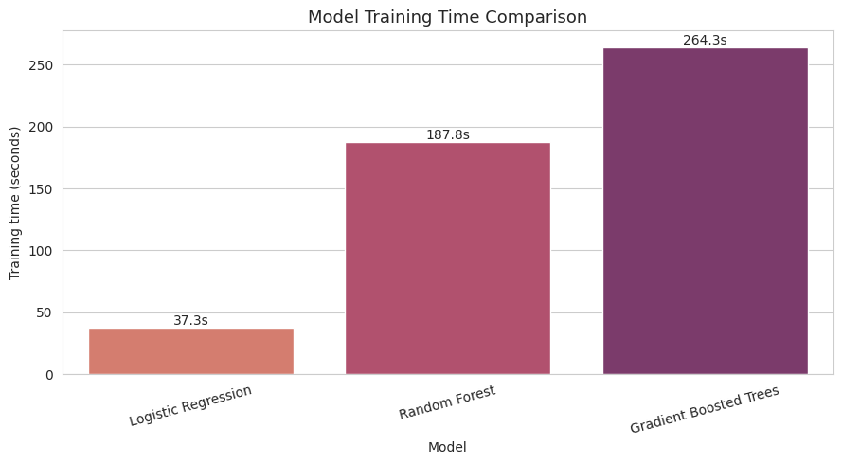
Figure 5: Model Training Time Comparison
The results showed that Gradient Boosted Trees have the best overall classification ability with ROC-AUC of 0.9127 and fraud recall of 0.8013 while the random forest had an ROC-AUC of 0.8959 and fraud recall of 0.7644. Logistic Regression, although less accurate (ROC-AUC of 0.8191), needed much less training time. So, the assessment exhibits a compromise between predictive performance and cost to computation. GBT took about 264.27 seconds, while Random Forest took 187.83 seconds and Logistic Regression took only 37.31 seconds.
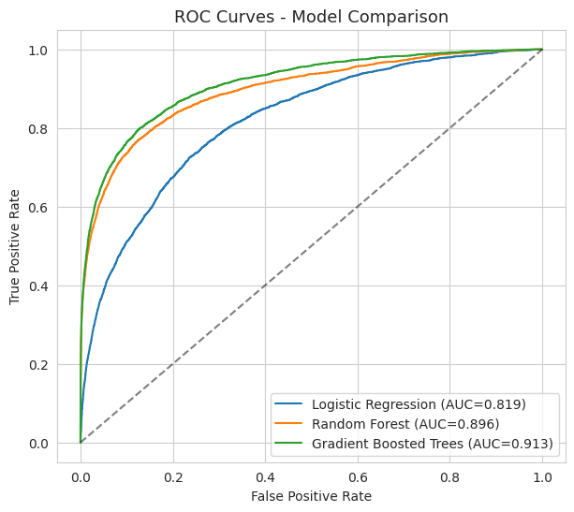
Figure 6: ROC Curves
Further evidence of the best discrimination between legitimate and fraudulent transactions comes from the ROC curves and comparison charts. To consider the scalability, different training-data sizes were used, such as 25%, 50% and 100% of the entire training dataset, and not only the prediction accuracy was taken into consideration but also the computational efficiency.
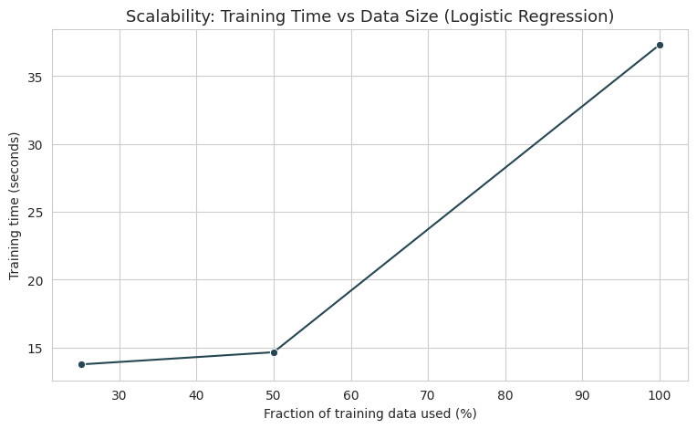
Figure 7: Scalability
The overall assessment shows that the project achieved the technical goals. However, it is not documented that external beneficiaries were completed with evidence of project evidence of external beneficiary testing and formal user acceptance results.

5.1 User Acceptance Tests
UAT ID | Test | Expected Result | Outcome
UAT-01 | Load transaction dataset | Dataset loads successfully in PySpark | Pass
UAT-02 | Preprocess transaction data | Missing values and categorical variables are processed successfully | Pass
UAT-03 | Train Logistic Regression | Model trains and generates predictions | Pass
UAT-04 | Train Random Forest | Model trains and generates fraud predictions | Pass
UAT-05 | Train GBT | Model trains and generates fraud predictions | Pass
UAT-06 | Calculate evaluation metrics | Accuracy, precision, recall, F1 and ROC-AUC are generated | Pass
UAT-07 | Display confusion matrix | Fraud and legitimate predictions are visualised | Pass
UAT-08 | Compare models | Performance and training time can be compared | Pass
UAT-09 | Test scalability | Different dataset sizes can be processed and timed | Pass
UAT-10 | Identify best model | GBT is identified as the highest ROC-AUC model | Pass

Conclusion

6.1 Summary of Project Achievements
The project was a success and explored the use of scalable machine learning models for financial fraud detection using big data technologies. The research was designed to create a PySpark based fraud detection framework which included the functionalities of data preprocessing, feature engineering, model development, performance evaluation and scalability analysis. The project required to fill the research gap by comparing Logistic Regression, Random Forest and Gradient Boosted Trees under distributed machine learning. The goal of the research was to enhance the Fraud Detection with respect to predictiveness and computational efficiency.
The experimental results showed that there were significant differences among the three models. Logistic Regression took the least number of seconds in training (37.31 seconds) but the lowest ROC-AUC (0.8191). In the case of Random Forest, the predictive performance is better with 0.8959 ROC-AUC and the training time is about 187.83 seconds. Gradient Boosted Trees had the best overall discrimination, at 0.9127 ROC-AUC and 80.13% fraud recall, but the training time was the longest using about 264.27 seconds. These findings highlight the balance between model performance and efficiency and contribute to the project's goal of examining scalable fraud detection strategies.

6.2 Future Prospects
The identified future project objective of improving the framework for real-time fraud detection environments could be explored. Larger and more diverse financial datasets could be explored, as could other machine learning and deep learning algorithms, as well as novel approaches to hyperparameter optimization and handling extreme class imbalance. The PySpark implementation might also be expanded to a bigger distributed computing cluster to give more evidence for scalability. Further studies could explore automated model retraining to adapt to evolving fraud patterns, explainable AI to enable financial analysts to grasp fraud predictions, and integration with real-time transaction monitoring systems. The development may make the framework more useful for banks, FinTech organisations, cybersecurity analysts and online payment platforms to prevent financial fraud more quickly and effectively.

References
‌Alketbi, A. (2025). Real-Time Fraud Detection using Big Data Real-Time Fraud Detection using Big Data. https://repository.rit.edu/cgi/viewcontent.cgi?article=13380&context=theses
‌Bello, A., & Olufemi, K. (2024). Artificial intelligence in fraud prevention: Exploring techniques and applications challenges and opportunities. Computer Science & IT Research Journal, 5(6), 1505–1520. https://doi.org/10.51594/csitrj.v5i6.1252
‌Cheng, C. (2025). Research on Fraudulent Transaction Detection. Applied and Computational Engineering, 158(1), 35–40. https://doi.org/10.54254/2755-2721/2025.tj23322
‌Gupta, R., Jindal, R., Naik, A., & Tripathi, A. (2025). Applying Logistic Regression for the Detection of Fraudulent Banking Transactions. ResearchGate, 47(02). https://www.researchgate.net/publication/392331388_Applying_Logistic_Regression_for_the_Detection_of_Fraudulent_Banking_Transactions
‌Hareram, S. E. (2025). Technical Review: Apache Spark and PySpark for Distributed Data Processing. Zenodo. https://doi.org/10.5281/zenodo.16491755
Liu, C., Tang, H., Yang, Z., Ke, Z., & Cha, S. (2025). Big Data-Driven Fraud Detection Using Machine Learning and Real-Time Stream Processing. arXiv.Org. https://arxiv.org/abs/2506.02008
‌Naghipour, S. A., far, & Nazari, R. (2025). Fraud Analytics with Big Data: A Literature Review on Machine Learning Algorithms in Bankruptcy Prediction and Financial Fraud Detection. National Conference on Information Technology, Nanotechnology, Artificial Intelligence and Technological Futures Studies. https://www.researchgate.net/publication/397446053_fraud_analytics_with_big_data_a_literature_review_on_machine_learning_algorithms_in_bankruptcy_prediction_and_financial_fraud_detection
‌Owen, A., Emma, O., & Adams, R. (2024). Evaluating the Role of Class Imbalance in Fraud Detection Algorithms. In ResearchGate. unknown. https://www.researchgate.net/publication/388817710_Evaluating_the_Role_of_Class_Imbalance_in_Fraud_Detection_Algorithms
Theodorakopoulos, L., Theodoropoulou, A., Tsimakis, A., & Halkiopoulos, C. (2025). Big Data-Driven Distributed Machine Learning for Scalable Credit Card Fraud Detection Using PySpark, XGBoost, and CatBoost. Electronics, 14(9), 1754. https://doi.org/10.3390/electronics14091754
Wiltshire, D., & Alvanides, S. (2022). Ensuring the ethical use of Big Data: lessons from secure data access. Heliyon, 8(2). https://doi.org/10.1016/j.heliyon.2022.e08981
‌

